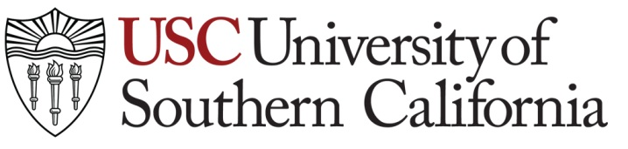

University of Southern California Los Angeles, California 90089-0182

Guidelines for use of Gift Agreement (Physical Items)

- This Gift Agreement for Physical Items form is only to be used for items that are urgently needed by Keck Medicine of USC, Keck School of Medicine or any other medical/health facilities at USC related to the crisis created by the current COVID-19 pandemic.

- Development officers or staff coordinating the gift must make sure items are received by the appropriate department at USC.

- Generally, in the case of individual Donors who intend to take a deduction of more than $5,000 on their tax returns for the gift, the Donor must file a Form 8283 with their tax return and the Donor must also obtain a qualified appraisal. This is an IRS requirement and not a USC requirement.

  - Please note that donation of use of space (e.g., use of hotel rooms, office space, use of houses listed on AirBnB) is not considered deductible under IRS rules and not considered a gift under CASE guidelines.

